**Contributor: Deborah Caplow**

**Goitia, Francisco**

Born: Fresnillo, 1882; Died: Xochimilco, 1960

Francisco Goitia, born in Fresnillo in the state of Zacatecas, studied painting at Mexico City’s Academy of San Carlos from 1898 to 1904; his teachers were José Maria Velasco, Felix Parra, Julio Ruelas, Leandro Izaguirre, and Germán Gedovius. His fellow students included **Diego Rivera,** Roberto Montenegro and Alfredo Ramos Martínez. In 1904 he left Mexico to study art in Spain and Italy, mostly in Barcelona. In Spain he saw the paintings of Velázquez, El Greco, and Goya, and was particularly impressed by Goya’s *Disasters of War* etchings. Returning to Mexico 1912, Goitia joined the Mexican Revolution in the army of Francisco (Pancho) Villa and worked as an artist under the command of General Felipe Angeles. His paintings from 1914 to 1918 depict the atrocities he saw in the aftermath of battle, in contrast to earlier work, which consisted of portraits, landscapes and still-lifes in an **Expressionistic, Post-Impressionis**t mode. After the Revolution, the artist created paintings that explored themes of death, such as his 1927 *Tata Jesucristo*, his *Paisaje de Santa Monica* (Landscape of Santa Monica) of 1950 and *Cabeza de ahorcado* (Head of a Hanged Man), of 1959. In the 1950s, Goitia also produced a number of self-portraits that showcased his eccentric personality.

Goitia is known for his morbid preoccupation with death. After studying art in Europe for eight years, he joined the Mexican Revolution as an artist and witnessed the horrors of combat. Based on first-hand observation, his wartime works are disturbing paintings, such as his horrific *La bruja* (The Witch), of c.1916, which portrays the decaying face of a corpse, and chilling images of hangings in *Paisaje de Zacatecas I* (Landscape of Zacatecas I*)*, c. 1914, and *El ahorcado* (The Hanged Man) of 1917. When the Revolution ended, Goitia worked with anthropologist Manuel Gamio, who at that time was involved in the excavations of the site of Teotihuacán near Mexico City. Goitia made numerous drawings of the indigenous inhabitants of the area around Teotihuacán for Gamio*.*

In the late 1920s Goitia moved to Xochimilco outside of Mexico City, where he lived for the rest of his life in deliberate poverty, a result of his eccentric personality and extreme religiosity; he never married. In spite of this, he was active in the arts in Mexico City. He taught art at the Escuela Nacional de Artes Plásticas (formerly the Academy of San Carlos) and in primary schools for many years. Both realist and visionary, Goitia painted in his own dynamic style, with affinities to the dark view of humankind expressed in the paintings of **Jose Clemente Orozco**. However, he had no interest in mural painting and worked in virtual isolation. Nonetheless, he was respected by his contemporaries, and he served as the president of the Frente Nacional de Artes Plasticas (National Front for the Arts) in 1955. Anita Brenner devoted an entire chapter to Goitia in her 1929 book *Idols Behind Altars*, based on personal interviews with him, and the Metropolitan Museum included Goitia in the exhibition and catalogue *Mexico: Splendors of* *Thirty Centuries*.

In 1927, Goitia painted *Tata Jesucristo*, his most well-known painting, during a prolonged stay in the mountain village of San Andrés in the State of Oaxaca. The image depicts two indigenous women during the Days of the Dead who sit on the ground crying, with a candle lighting the darkness and marigolds in the foreground.

[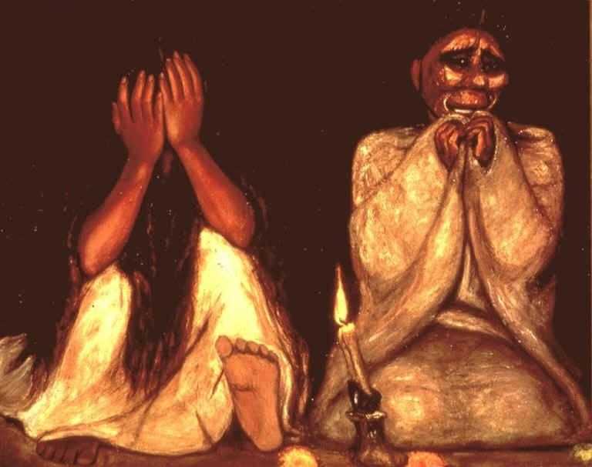](http://www.google.com/url?sa=i&rct=j&q=&esrc=s&source=images&cd=&docid=Zqam4srm37_UHM&tbnid=yiSusU1eCR4h1M:&ved=0CAUQjRw&url=http%3A%2F%2Fwww.escueladeespectadores.cl%2Faudioteca%2Flos-papeleros%2Flos-papeleros%2Fisidora-y-su-responsabilidad-social%2F&ei=mCvPUrCkI8LN2QXqkYDICA&bvm=bv.59026428,d.b2I&psig=AFQjCNGcN0OC3R8S7Y0XkcLE35BCNRpBwA&ust=1389395223764797)

Francisco Goitia, Tata Jesucristo, oil on canvas, 1927, 85 x 107 cm

https://www.google.com/search?q=tata+jesucristo&client=firefox-a&hs=dqz&rls=org.mozilla:en-US:official&source=lnms&tbm=isch&sa=X&ei=ctTOUsrCH9TioASRh4LwDw&ved=0CAkQ_AUoAQ&biw=1440&bih=693#facrc=_&imgrc=yiSusU1eCR4h1M%253A%3BZqam4srm37_UHM%3Bhttp%253A%252F%252Fwww.escueladeespectadores.cl%252Fwp%252Fwp-content%252Fuploads%252F2011%252F02%252FTata-Jesucristo.-Francisco-Goitia.-_leos-sobre-tela.-1926..jpg%3Bhttp%253A%252F%252Fwww.escueladeespectadores.cl%252Faudioteca%252Flos-papeleros%252Flos-papeleros%252Fisidora-y-su-responsabilidad-social%252F%3B768%3B607

Two other impressive works are *Viejo en el muladar* (Old Man Seated on the Trash Heap), of 1926-27, and *Paisaje de Zacatecas con ahorcado II* ( Landscape of Zacatecas with Hanged Man II), of 1959, paintings that demonstrate Surrealist influence. Goitia exhibited little during his lifetime, and gave most of his work to the Mexican government in exchange for a small pension. His first exhibition was held in Zacatecas at the Biblioteca Cervantes in 1946, and in 1957 there was a retrospective exhibition of Goitia’s work at the gallery Las Pérgolas de la Alameda in Mexico City. In 1958 he received the international prize for *Tata Jesucristo* at the First Inter-American Biennale in Mexico City. He died in Xochimilco in 1960.

Goitia’s reputation has grown since his death, as evidenced by a number of monographs published in recent years, and two films based on his life, the full-length *Goitia, un dios para si mismo* (Goitia, a God in Himself), of 1989, and a short called *Los colgados de Francisco Goitia* (The Hanged Men of Francisco Goitia), made in 2010. The Museo Francisco Goita, holding much of his art, and works by other artists, was established in Zacatecas in 1978.

**References and Further Reading:**

Brenner, A. (1929) *Idols Behind Altars*, New York, Payson and Clarke, pp. 288-302..

Luna, A. (1992) *Goitia*. Mexico City, Hachette Latinoamérica.

Luna, A. (1987) *Francisco Goitia total*. Mexico City, UNAM.

Goitia*.* F., Fernández, B. and Yampolsky, M. (1988) *Goitia*. Mexico City, ISSSTE, 1988

Goitia*.* F., (2000) *Francisco Goitia, pintor del alma del pueblo Mexicano*. Mexico City, Fondo Editorial de la Plástica Mexicana.

Metropolitan Museum of Art (1990) *Mexico: Splendors of* *Thirty Centuries*. New York, Metropolitan Museum of Art, pp. 562-575.

**Filmography:**

*Goitia, un dios para sí mismo* (Goitia, a God in Himself) (1989, 2000), video, New York, Latin American Video Archives.

*Los colgados de Francisco Goitia* (The Hanged Men of Francisco Goitia) (2010), Karla Castañeda, director, Mexico City, IMCINE, CANIETI.

**Exhibitions:**

Biblioteca Cervantes, Zacatecas, 1946; Galería Las Pérgolas de la Alameda, Mexico City, 1957; First Inter-American Biennale, Mexico City, 1958.

List of Works:

*La bruja* (The Witch),1916, oil on canvas.

*Viejo en el muladar* (Old Man Seated on the Trash Heap), 1926-27, oil on canvas.

*Tata Jesucristo*, 1927, oil on canvas.

*Paisaje de Santa Monica* (Landscape of Santa Monica), 1950, oil on canvas.

*Cabeza de ahorcado* (Head of a Hanged Man), 1959, oil on canvas.

*Paisaje de Zacatecas con ahorcado II* (Landscape of Zacatecas with Hanged Man II), 1959, oil on canvas.